CITATION OPERATIONS

FIELD GUIDE

Rev 2.4

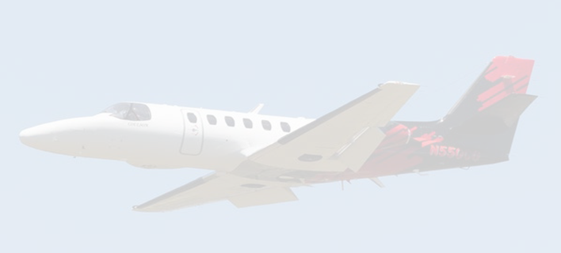
Contents
1. OVERVIEW 1
2. PRE-FLIGHT 1
Weather and Regional Awareness 1
Performance Planning 1
Flight planning and ATC 1
Ramp Safety and Weather Protection 2
SMS Flight Risk Assessment (FRAT) 2
Professional Conduct at Bases 2
State of Readiness 2
The Air Tactical Group Supervisor (ATGS) 2
ATGS Briefing 3
ATGS Debriefing 3
3. FLIGHT FOLLOWING 3
2. Non-Agency or Reposition Flights 3
4. POST FLIGHT/POST DAY DUTIES 4
Electronic Flight Log (EFL) 4
Logbooks and Fuel Receipts 5
Aircraft Cleanliness 5
5. AIRCRAFT OUT OF SERVICE (OOS) 5
6. FUEL PROCEDURES 6
7. THERMAL, CA AND PORT ALBERNI, BC BASES 6
Thermal, California 7
Port Alberni, British Columbia 7
8. CREW CHANGE PROCEDURES 7
9. EXPENSES 7
10. BOOKING FLIGHTS 8
11. HOTELS 8
12. RENTAL CARS AND CDP CODES 8
13. INCIDENT BUSINESS SYSTEM (IBS) 9
14. FMC UPDATES (EVERY 28 DAYS) 9
NAV and TAWS Airport DB Updating is the responsibility of the pilot. 9
15. KEY CONTACTS 11

OVERVIEW
This guide outlines the day-to-day operational responsibilities of an Air Attack/Citation Captain. It is intended as a practical field reference rather than a regulatory document. Procedures and expectations will continue to evolve, and pilot feedback is encouraged to keep the document accurate and useful.

PRE-FLIGHT
While on contract, aircraft availability start times may vary based on regional fire activity and operational tempo. The ATGS will normally advise of the anticipated start time for the following day. Pilots are expected to complete the pre-flight inspection early enough to allow any maintenance or operational discrepancies to be identified and resolved before the requested availability time, ensuring aircraft readiness is not compromised. All pre-flight duties should be complete and the aircraft and pilot should be ready for dispatch at the requested start time.
Although dedicated maintenance personnel travel with the aircraft, airworthiness and operational readiness are a shared responsibility between flight crew and maintenance. Early identification and clear communication of discrepancies—no matter how minor—are essential to prevent delays.

Weather and Regional Awareness
Each operational day begins with a thorough review of the regional weather picture. Although the Citation 550 provides considerable flexibility and access to a broad range of airports at the end of a fuel cycle, the PIC is expected to identify suitable diversion options in advance. This requires evaluating forecasts, weather trends, and NOTAMs for suitable airports throughout the operating area.
Strong regional knowledge is critical. Fuel stops closer to the fire area are frequently used to maximize on-station time, and diversions to other incidents are common. Dispatch distances may vary from approximately 10 to 300 miles, making continuous awareness of regional weather conditions essential for safe, efficient mission execution.

Performance Planning
Certain airports impose MTOW limitations on the Citation 550, particularly as temperatures increase through the season. Aircraft performance must be calculated in accordance with the AFM while balancing the need to maximize mission endurance for the Agency.
When based at a performance-limiting airport, use forecast peak temperatures for the next several days to calculate MTOW. If a reduced fuel load is required, notify the ATGS as early as possible.
Prior to repositioning to a performance limiting airport, discuss possible performance limitations with the ATGS, as these may affect the decision to relocate to the proposed airport.

Flight planning and ATC
The transponder Aircraft ID shall be set to the Coulson callsign (e.g., CUL552, “Coulson 552”) for all flights, and all flight plans and ATC communications shall use the Coulson callsign. For USFS missions, set squawk code 1255, the standard code for U.S. firefighting aircraft. ATC may assign a different code when operating in Class B airspace; upon exiting, ATC will typically instruct you to “squawk tactical,” which refers to squawk 1255.
Flight Plans, if used, should include the STS Special Handling code “FFR”. Normally we use ForeFlight to file but in the case where we cross the border, we will use FltPlan.com for its ability to file eAPIS manifests. Ensure crew and passenger information is up to date and passports are valid.

The log in information for FltPlan.com:
User – ETAOPS
Password – challenger1048

Ramp Safety and Weather Protection
Remain alert to weather conditions that could pose a risk to the aircraft while parked. The USFS supports hangar use or repositioning to a safer location when necessary to protect the aircraft and prevent avoidable out-of-service events. Protecting the aircraft from weather damage is a core PIC responsibility.

SMS Flight Risk Assessment (FRAT)
Complete one FRAT per day and save it as Pending early in the shift—ideally during the walk-around rather than after dispatch. If operational or environmental conditions change significantly or worsen, update the FRAT accordingly.
Save the FRAT as Final prior to departure, or at the end of the duty period on a no-fly day. Normally, using one FRAT per day for multiple flights is acceptable unless conditions, type of flight or crew members/passengers on board change.

Professional Conduct at Bases
Aircraft are frequently based at Air Tanker Bases. Crews represent Coulson Aviation as guests and professionals. Wear a uniform shirt and closed-toe shoes, maintain clean work areas, and assist base personnel when appropriate.

State of Readiness
When operating from a tanker base, crews shall maintain a high state of readiness at all times. All required items should be on board the aircraft in anticipation of a dispatch, keeping in mind that you may be diverted and not return to your airport of departure. Flight gear should be staged and crews should be aware of current conditions in the area to ensure a prompt and efficient response to dispatch.

The Air Tactical Group Supervisor (ATGS)
The Air Tactical Group Supervisor (ATGS) is a non-pilot crewmember and a critical part of the Air Attack team. While the pilot is responsible for the safe operation of the aircraft, the ATGS is responsible for aerial supervision, tactical coordination, and execution of the fire mission. Effective Air Attack operations depend on a high level of trust, communication, and professionalism between the pilot and the ATGS.
Strong CRM between the pilot and ATGS is essential. The pilot must actively communicate relevant information that may affect safety, workload, or mission effectiveness, including aircraft performance considerations, weather trends, airspace constraints, fuel state, system anomalies, or anticipated operational limitations. Transparent communication allows the ATGS to make informed tactical decisions and reinforces confidence in the aircraft and flight crew.
Equally important is the pilot’s responsibility to keep the ATGS informed of any developing issues—no matter how minor they may appear. Early disclosure of concerns helps prevent surprises, supports shared decision-making, and preserves trust. Withholding information, minimizing issues, or delaying communication can erode CRM and place unnecessary pressure on both crew-members.
A professional Air Attack crew functions as a cohesive unit. Mutual respect, clear communication, and consistent information flow between the pilot and ATGS are foundational to safe, effective aerial supervision and mission success.

ATGS Briefing
After the Base Briefing is complete a briefing with the ATGS should be completed. Points to be discussed:
- Coulson FRAT
- USFS FRAT
- Detailed aircraft performance (ATGS will need to see W&B and performance charts)
- MELs and relevant aircraft information
- Weather, SIGMETs, NOTAMs

ATGS Debriefing
While not mandatory, a debrief provides a valuable opportunity to ask questions and reinforce learning. The ATGS typically brings decades of wildfire experience, both on the ground and in the air, and is a key resource for pilots seeking to improve performance and progress to airtanker operations.

FLIGHT FOLLOWING
Coulson aircraft operating under USFS contract use two forms of flight following.
- Automated Flight Following (AFF)
  - AFF is the primary method used by the USFS to monitor aviation assets during agency flights.

Non-Agency or Reposition Flights
  - In these cases, Coulson substitutes AFF with group messaging via WhatsApp.
Each message should include:
- Aircraft
- Departure
- Destination
- ETA
- POB
- Fuel endurance
Flight Following Contact
- Steve Klahm – (250) 218-2036

POST FLIGHT/POST DAY DUTIES
Post-flight, crews are expected to conduct a deliberate assessment of aircraft condition and system performance, identifying any abnormalities, trends, or degraded functionality observed during the mission. Discrepancies should be documented accurately with as much information as possible, using pictures or videos where applicable. Any and all discrepancies should be communicated promptly to maintenance. Timely post-flight reporting supports effective troubleshooting, informed downline planning, and clear decision-making regarding the application of an MEL or the need to remove the aircraft from service.
At the end of each operational day, pilots submit final documentation associated with daily operations. This includes:
- Electronic Flight Log (EFL)
- Aircraft log sheets
- Fuel receipts

Electronic Flight Log (EFL)
The EFL tracks block and flight hours, aircraft availability, low-level mission time, and crew flight-time limitations. It also feeds USFS serviceability and billing systems.
Mission Time
Low-level time is tracked separately to support Textron Aviation’s revised Citation 550/560 inspection program which has recently been amended. The latest letter states: “The Coulson Aviation equivalent flight hour factor must be applied to all Air Attack / LeadPlane mission flight hours, including transit time from the forward operating base to the fire zone. The operator is not required to apply the Coulson Aviation equivalent flight hour factor to flights classified as typical executive transport usage (High altitude cruise from point A to point B).” This means that the entire flight time associated with a fire mission must be logged as mission time, including transit time. The only flight that can be be logged normally (not considered mission/low-level time) is a point-to-point flight.
Enter mission time in the low-level window of the daily log in the Coulson App.
Time Accuracy and Billing
Pilot-entered times must align with ATGS records. Twice monthly, billing packages are reviewed between Coulson and the Agency. Discrepancies delay billing until corrected.
Downstream changes are extremely difficult once the IBS has been submitted. To avoid delays, verify all times daily with the ATGS and ensure the EFL entries match the ATGS-provided times exactly, to the minute. The ATGS will send the IBS to you prior to submitting and this will be your last chance to catch any discrepancies.
All times are entered in LOCAL time, not UTC.
Daily EFL Distribution
- aviationfixedwingdailies@coulsonaviation.com
- aviationfixedwingpilots@coulsongroup.com
- Koen.baglien@coulsonaviation.com
- ops@paragonairways.com
Use a subject line format such as “N552CG DAILY 31JAN26.” Reports are expected to be submitted at the end of the duty day, as they must be circulated to the USFS that evening. Next-day submissions should be limited to exceptional circumstances only. If fuelling is deferred until the following morning, the report must still be submitted that night; the EFL may be updated and resubmitted after fuelling.
Times derived from the EFL are the authoritative source for block and flight hours across the fleet. Cross-check the EFL spreadsheet against AJL totals prior to distributing the daily report to minimize errors and avoid follow-up from Records

Logbooks and Fuel Receipts
Logbook entries are completed in local time using EFL-calculated block and flight times. To reduce end-of-day workload, track legs in the EFL throughout the day and transcribe accordingly. Scan the AJL and email PDF to citationajl@coulsonaviation.com
Fuel is purchased using Coulson-provided World Fuel Service cards. Scan receipts and email PDFs to: fuel@coulsonaviation.com

Aircraft Cleanliness
The Captain is responsible for ensuring the aircraft remains clean and professional in appearance. Exterior surfaces should be cleaned as required, with leading edges and the windshield cleaned at least daily. The interior shall be kept orderly at all times. Coordinate with maintenance as necessary to maintain overall aircraft condition.

AIRCRAFT OUT OF SERVICE (OOS)
Aircraft OOS events will occur during field operations. Refer to the seasonal OOS reporting memo (e.g., 2025 USA Out of Service Reporting) for current contacts and procedures.
Timely notification to the USFS is essential. The Captain serves as the primary liaison between the Agency and Coulson.
Once a repair plan is established with maintenance:
- Notify the tanker base manager, if applicable.
- A memo will be emailed at the beginning of the season with current OOS email addresses for each aircraft. This memo will also be uploaded to the Coulson Aviation Documents Folder on ForeFlight. Ensure you email an OOS notification stating the issue and estimated return to service to the applicable email address for your aircraft.
- Call the COR and send a follow-up text to the AMI and notify of status.
- Ensure that the discrepancy is entered into the Aircraft Journey Logbook.
- Ensure that the Paragon 302 – Discrepancy form (available on JetInsight app) is filled out and a copy is emailed to our Part 135 certificate holder at maintenance@paragonairways.com and ops@paragonairways.com Include details on the course of action being taken to clear the discrepancy and that the aircraft is out of service. Once the discrepancy is cleared, the mechanic will complete the maintenance action side of the 302 form and this will need to be emailed to Paragon prior to returning to service. This step needs to be completed for all aircraft discrepancies, not just for aircraft on contract.
- If the aircraft needs to be ferried for repair, a ferry permit must be issued and the ATBM, AMI, COR and USFS Dispatch need to be informed prior to aircraft movement.
- If a Functional Check Flight is required prior to return to service, the logbook must document this requirement and the necessary sign off should be obtained, recorded and issued to the AMI. The ATBM should be made aware of the FCF as well.
- When the aircraft is once again serviceable, inform relevant parties through the OOS email address.
- Coordinate with the mechanic to ensure all paperwork is complete and forward documentation via the OOS email address.
- Wait for approval to return to service.
Report all defects to your mechanic promptly, regardless of perceived severity, to minimize downtime.

FUEL PROCEDURES
Fuel dispatches offer a better rate per gallon and are therefore the preferred method of purchasing fuel. These can be arranged prior or last minute and can be arranged to be a standing fuel order, valid for several days.
World Fuel and AEG fuel coordination contacts:
- fuel24@wfscorp.com
- dispatch@aegfuels.com
Aircraft carry WFS/Avcard fuel cards as the backup payment method.

THERMAL, CA AND PORT ALBERNI, BC BASES
Pilots may travel to Thermal or Port Alberni to deliver or retrieve aircraft. Each base has unique logistical considerations.
Prior to travel, notify CGtrips@coulsonaviation.com so accommodations and ramp access can be arranged. Ramp space is limited at both locations.

Thermal, California
Hotel accommodations are arranged through Coulson travel contacts. Do not book independently:
- shannon.kimball@coulsongroup.com
- darren.moore@coulsongroup.com
- travel@coulsongroup.com
Coulson maintains a fuel account with Atlantic FBO, the preferred provider at Thermal.
Access Codes
- Car Gate: 0810
- Hangar Padlock: 0777

Port Alberni, British Columbia
Lodging is coordinated through:
- alberni.rooms@coulsongroup.com
Rental cars arriving via Nanaimo may be dropped at the Port Alberni airport and returned by maintenance personnel.
Gate Access Code: No longer available – call the phone number on the gate

CREW CHANGE PROCEDURES
At the end of shift, complete a crew handover form and email it to the inbound crew. CC the Operations Manager, Chief Pilot, and Fleet Assistant Chief Pilot. This applies regardless of whether a face-to-face handover occurs.

EXPENSES
Expense reports are submitted monthly:
- USD cards: cutoff on the 26th
- CAD cards: cutoff on the 15th
Upload legible receipts in Concur. When receipts are unavailable, supporting photos may be used.
For temporary credit-limit increases, contact:
- courtney.schut@coulsongroup.com
- caedon.markin@coulsongroup.com
- jim.male@coulsongroup.com
Medical expenses are reimbursable. Pilots remain responsible for maintaining valid medical certification.

BOOKING FLIGHTS
- All business travel bookings must be made either through FCM/Concur, or where applicable the United Airlines for Business portal. Personal credit cards may only be used with our travel agency (FCM) or Concur.
- Flights should be booked as return airfares as far in advance as possible to manage costs and seat availability. This may not always be possible with aircraft on contract, as last minute moves are possible.
- Economy airfare must be booked for all domestic and transborder flights. Seat upgrade allowances are $200 on domestic flights or $600 for long haul flights (over 8 hours consecutive flight time), where warranted.
- Any seat upgrades or exceptions to policy require prior written approval and must be booked through the approved channels to be eligible for reimbursement.

If a flight price appears unusually high for your routing (over $2000 on international flights) it must be flagged through the travel department prior to booking so options can be reviewed.

If you need assistance or are unsure how to proceed, please contact the Travel Department before deciding – they’re happy to help.
- shannon.kimball@coulsongroup.com
- darren.moore@coulsongroup.com

HOTELS
During contract operations, lodging is covered by the USFS. Communicate daily hotel costs to the ATGS for tracking. Use government rates when available. The USFS contract number is printed on the back of your Coulson ID card.
Off-contract lodging follows Coulson policy for the applicable country.

RENTAL CARS AND CDP CODES
Preferred booking method is Concur.
CDP codes:
- Hertz: 2216352
- Budget: R884800
Rental cars during contract operations require ATGS approval unless associated with training or Thermal/Port Alberni operations. Personal use of CDP codes is permitted.

INCIDENT BUSINESS SYSTEM (IBS)
IBS tracks contract costs and supports agency billing. Times are recorded from off-block to in-block. The ATGS enters lodging, hangar, and FBO charges.
Request daily IBS summaries from the ATGS to verify accuracy and ensure costs are correctly attributed.
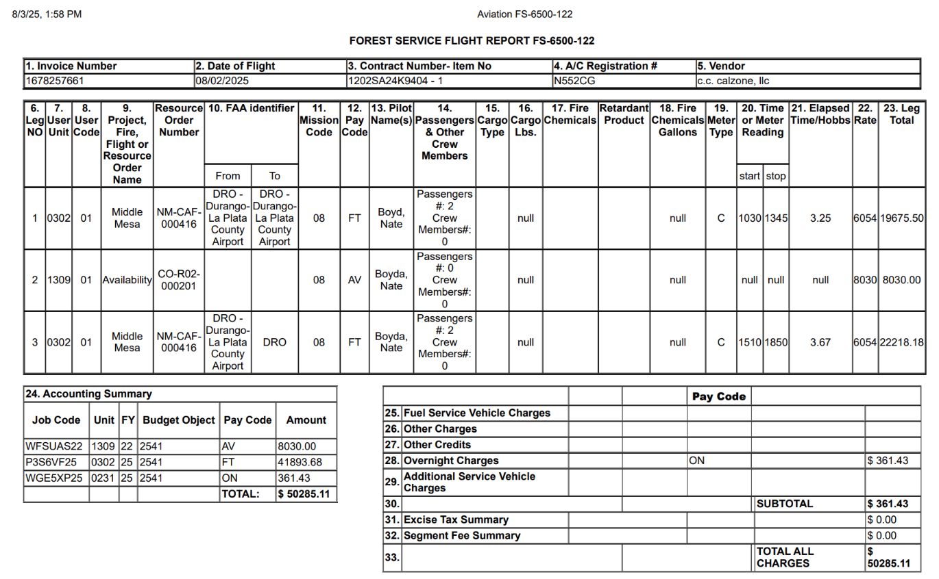

FMC UPDATES (EVERY 28 DAYS)

NAV and TAWS Airport DB Updating is the responsibility of the pilot.
- USBA Flash drive is required, must be 32gb or smaller, formatted in FAT32(default).
Recommend Scandisk Cruzer Blade 8gb
- Apple computers do not work
- NAV and TAWS Airport data bases are loaded separately , use 2 flash drives for ease,
both databases cannot be in the same uasc folder and multiple uasc folders cannot be on the same flashdrive.

- Insert NAV or TAWS Flash Drive into Windows PC.
- Go to https://secure.uasc.com/uninet/
- Login with:
Username – UniversalDB@coulsonaviation.com Password – CGdatabase#123
- Detailed instructions from Universal NAVDB Data Downloading Guide are listed below. Same process for NAV and TAWS Airport databases.
(download file, run app file, use wizard to extract into empty “uasc” folder on corresponding flash drive)
- Download the NAV DB file and load to the NAV flash drive.
- Download the TAWS Airport DB file and load to the TAWS flash drive.
- After adding the data, properly “eject” both flash drive’s from computer and remove.
- Insert NAV USB flash drive into Aircraft Solid State Data Transfer Unit located in the Aux Electrical Cabinet above the turret. Cover flips open.
- Power on aircraft and avionics, it Is recommended to use external power or complete with engines running.
- Turn on FMS via “On/Off/Dim” button. Allow boot up cycle to complete.
- Push “Data” button
- Select “Disk”
- Select “Disk Load”
- Verify the file displayed is the correct cycle/expiration date.
- Select “Load”
- Loading sequence begins automatically. Should take around 1-3 minutes. Once the load reaches 100%, “Load Status RCVD” will be displayed. And “Testing” will flash. Allow this to finish.
- Once the loading and testing has completed, “Load Status Pass” will be displayed. Select “Check All”. “Checking” will flash until complete, if there are no issues the screen will remain the same and now you can select “Return” to go back to the main “Data” menu.
- Verify load by selecting “Nav Data” and confirming active DB cycle and expiration date are correct.
- Now remove the NAV flash drive from SSDTU, and insert TAWS flash drive.
- Push “Data” button to return to main Data menu.
- Select “TAWS”
note: may have to wait for the TAWS selection to be enabled
- Select “Disk Load”
- Verify the file displayed is the correct cycle/expiration date.
- Select “Load”
- Loading sequence begins automatically. Should take around 1-3 minutes. Once it reaches 100%, “Automatically Resetting in 10 Seconds” message is displayed, allow to complete the reset.
- After reset, the screen will display an error message and tells you to select “TAWS”.
- Select “TAWS”, the main TAWS menu appears.
note: may have to wait for the TAWS selection to be enabled
- Navigate to page three in the TAWS menu to verify the displayed airport database cycle and expiration date are correct.
- Update is complete, power Off FMS by holding the “On/Off/Dim” button and selecting “shutdown”. Remove power from aircraft as required, remove flash drive and close cover.

KEY CONTACTS
NAME | ROLE/FUNCTION | EMAIL | PHONE
Chad Greening | Director of Flight Operations | Chad.greening@coulsonaviationusa.com | (503)705-6506
Shawn Dugan | Chief Pilot | Shawn.dugan@coulsonaviation.com | (541)408-7773
Steve Klahm | Assistant Chief Pilot – Citation | Stephan.klahm@coulsonviation.com | (250) 218-2036
Koen Baglien | Assistant Fleet Manager | koen.baglien@coulsonaviation.com | (763)-607-7577
Shannon Kimball | Travel Coordinator | shannon.kimball@coulsongroup.com
Darren Moore | Travel Coordinator | darren.moore@coulsongroup.com
Coulson Travel | Travel Department | travel@coulsongroup.com
World Fuel (WFS) | Fuel Coordination | fuel24@wfscorp.com
World Fuel Ops | International Trip Support | tsops@wfscorp.com
Fuel Receipts | Fuel Accounting | fuel@coulsonaviation.com
Citation AJL | Aircraft Journey Log Records | citationajl@coulsonaviation.com
Paragon Airways | Paragon Maintenance | maintenance@paragonairways.com
Fixed Wing Dailies | EFL Distribution | aviationfixedwingdailies@coulsonaviation.com
Fixed Wing Pilots | EFL/Pilot Distribution | aviationfixedwingpilots@coulsongroup.com
Paragon Ops | EFL/Operations Oversight | ops@paragonairways.com
Courtney Schut | Credit Cards/Accounting | courtney.schut@coulsongroup.com
Caedmon Markin | Credit Cards/Accounting | caedon.markin@coulsongroup.com
Jim Male | Credit Cards/Accounting | jim.male@coulsongroup.com

AS ALWAYS, IF YOU HAVE ANY QUESTIONS OR DOUBTS, PLEASE REACH OUT TO YOUR FLIGHT OPERATIONS TEAM.

